Source ID: 953484350

Source Title: Geological Survey of China

Agreement URL: <http://journal25.magtechjournal.com/Jwk_dzdc/CN/article/showOldVolumn.do>

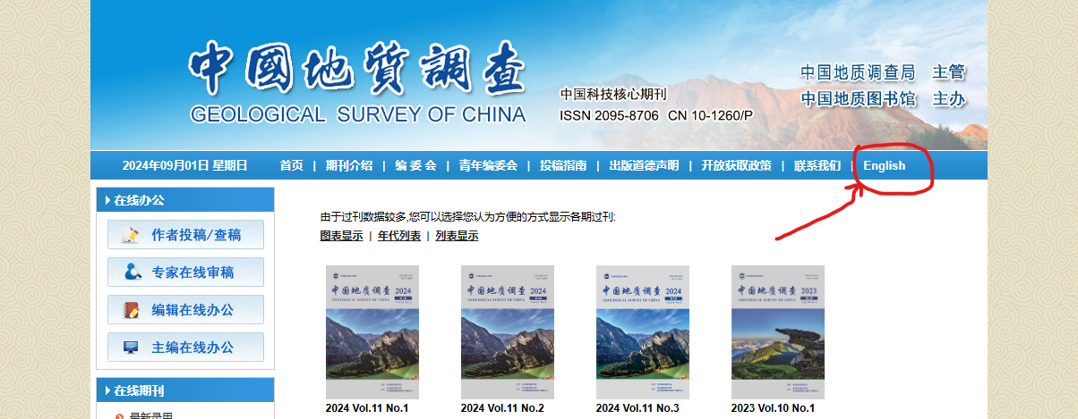

**Click here to change Language**

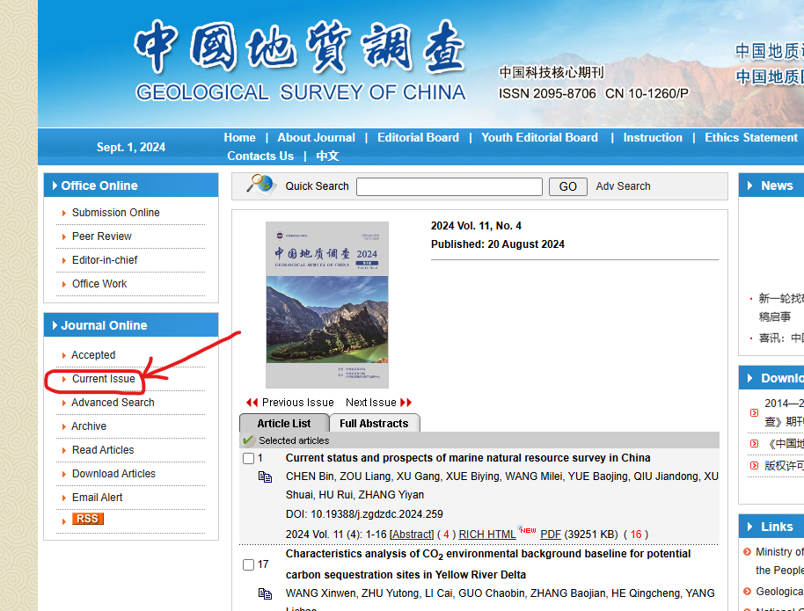

**Click here to access current issue**

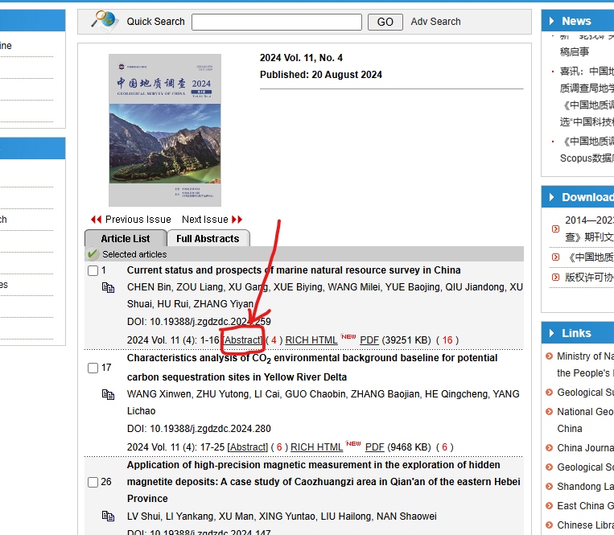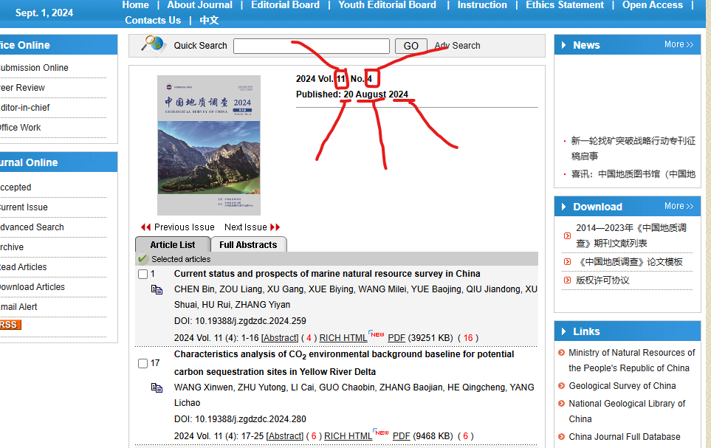

**Click here to access article metadata**

**Month**

**Year**

**Date**

**Issue**

**volume**

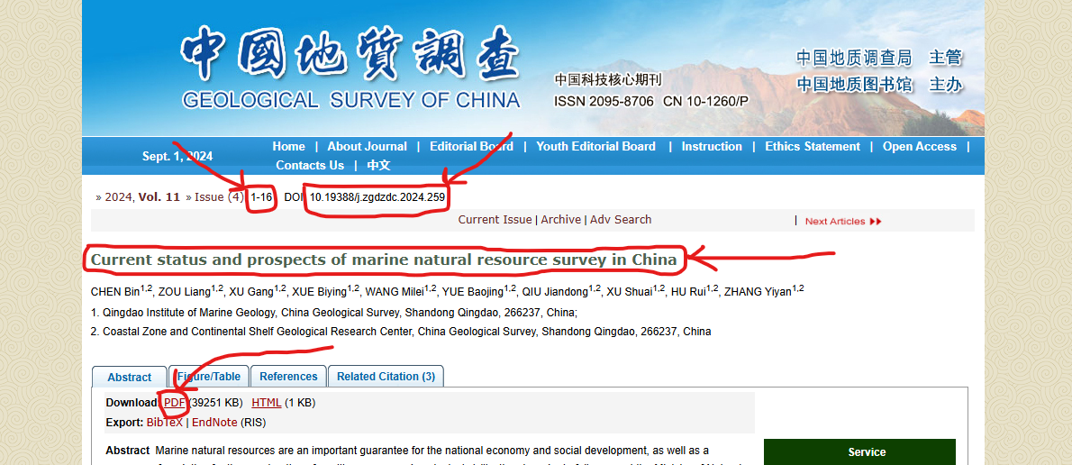

**Title**

**Click here to download PDF**

**Page Range**

**DOI**

**\*\* Both English & Chinese TOC need to include in template**